A Novel Method For Handwritten Digit Recognition System

Solution architecture
This section is an overview of the BMC Cloud Lifecycle Management solution architecture, including its major components and management layers.
BMC Cloud Lifecycle Management provides an end-to-end automated lifecycle management solution for cloud-based IT hosting environments. It focuses on the planning, governance, provisioning, operation, administration and maintenance of cloud services, the run-time environments and infrastructure resources needed to sustain them, and the management services that compose BMC Cloud Lifecycle Management itself.
BMC Cloud Lifecycle Management is a general-purpose, one-size-fits-all management solution for cloud hosting environments. It can manage environments that reside entirely on-premise or off-premise, and hybrid environments that are hosted partially on-premise and off-premise.
BMC Cloud Lifecycle Management can manage hosting environments that use physical or virtual compute, storage, and network resources. It can also manage environments that use cloud resources, including resources and services offered by other IaaS, PaaS and SaaS clouds. It can also support a cloud-of-clouds model, in which a cloud hosting environment managed by BMC Cloud Lifecycle Management is composed of two or more other cloud hosting environments also managed by BMC Cloud Lifecycle Management.
BMC Cloud Lifecycle Management is fully multitenant aware. It can support simultaneous use of the cloud by multiple tenants that can request, deploy, and operate services independently.
BMC Cloud Lifecycle Management architecture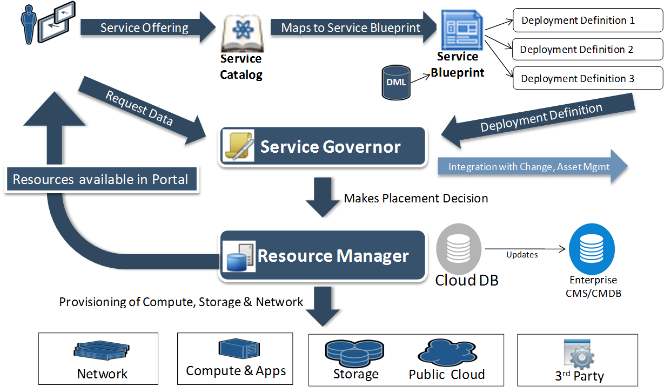

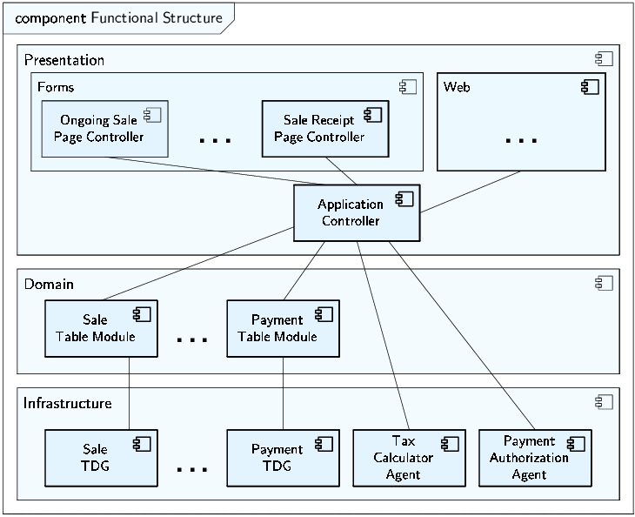
BMC Cloud Lifecycle Management supports the following types of users: cloud administrators and cloud tenants. Cloud administrators are responsible for the overall operation, administration, and maintenance of the cloud hosting environments, and for services hosted in the cloud on behalf of the cloud tenants.
Cloud tenants are the users of the cloud. Cloud tenants can be individuals or groups of individuals. Tenant users fill the following roles: cloud end users, who request services, and cloud organization administrators, who manage the portion of the cloud infrastructure and the services that belong to a given tenant.
For more information about BMC Cloud Lifecycle Management roles, see User roles and responsibilities.

Consoles
Cloud users access the cloud through the following consoles:
- BMC Cloud Lifecycle Management My Cloud Services Console — Enables users and administrators to request, deploy, and operate service offerings from the Service Catalog
- BMC Cloud Lifecycle Management Administration Console — Enables cloud administrators to manage the cloud and the services that it hosts
For more information about BMC Cloud Lifecycle Management Consoles, see Cloud end user - using My Cloud Services Console and Administration overview.

Service Catalog
The Service Catalog contains the service offerings that are available for consumption by cloud users. Cloud administrators maintain the Service Catalog by creating, modifying, and deleting service offerings. They can also control which offerings in the Service Catalog are available to each tenant. For more information about the Service Catalog, see Service Catalog overview.

Cloud Database
The Cloud Database contains operational state and configuration information about the objects managed by the cloud. These managed objects include service offering instances, virtual cloud resources, and physical and virtual infrastructure resources. If a compatible enterprise Configuration Management Database is present, you can synchronize the Cloud Database with it in real time.

Product Catalog and Definitive Media Library
The Product Catalog and Definitive Media Library (DML) list all software that can be provisioned in the cloud. The Product Catalog does not store the software itself. Instead, it contains a unique reference to each piece of software, while the software itself remains in native repositories such as the BMC BladeLogic Server Automation software repository or the Amazon AWS AMI repository.
The Product Catalog also contains software metadata, such as software and hardware requirements pertaining to software provisioning, as well as other data used during software configuration. Cloud administrators create and maintain entries in the Product Catalog by using interfaces provided by the Product Catalog.

Cloud blueprints
Cloud blueprints define cloud services and resources from different points of view. BMC Cloud Lifecycle Management uses the following cloud blueprints:
- Service blueprints describe the functional structure of a given service offering, including its functional components and communication paths. They also define how a service offering is to be deployed under different circumstances. Each service offering in the Service Catalog has a set of service blueprints used for its instantiation. Cloud administrators define and maintain service blueprints by using the BMC Atrium Blueprint Studio software. For more information about service blueprints, see Service blueprints overview.
- Network container blueprints define the physical and logical segmentation, and the architecture of the cloud network. Network container blueprints incrementally grow and organize the cloud capacity. Cloud administrators create and maintain network container blueprints by using the BMC BladeLogic Network Automation software. For more information about network container blueprints, see Importing network container blueprints.

Cloud infrastructure resources represent physical or virtual data center resources that host service offerings in the cloud. BMC Cloud Lifecycle Management uses compute, storage, network, and software infrastructure resources, including the following examples and other software deployable in the cloud:
- Firewalls
- Load balancers
- Local disks
- Routers
- SAN and NAS devices
- Virtual clusters
- Virtual hosts
For more information about infrastructure resources, see Resource types.

Cloud resources
Cloud resources are virtual resources used to abstract similar types of resources, as follows, and to establish a normalized interface for their management:
- network containers, see Network resources overview. Compute resource pool — Abstracts compute resources, including servers, virtual machines, and cloud compute capacity. For more information about compute resource pools, see Compute resources and compute resource pools overview.
- Network container — Abstracts cloud network designs. For more information about

Cloud providers
Cloud providers are software programs that act as element managers for different types of resources, platforms, and services consumed by the cloud. BMC Cloud Lifecycle Management uses the following provider types:
- Control — Controls cloud resources
- Telemetry — Obtains monitoring data about the hosted services and the cloud infrastructure
- Advice — Obtains advice about how to manage the cloud infrastructure and hosted services
- Resource — Allocates and provisions resources that are required for service hosting and normal operation of the cloud infrastructure
At installation, BMC Cloud Lifecycle Management includes the following providers, based on existing BMC products:
- BMC BladeLogic Server Automation — A control and resource provider for various types of infrastructure compute resources, such as physical servers, virtual machines, virtual machine clusters, and virtual cluster resource pools
- BMC BladeLogic Network Automation — A control and resource provider for network resource providers, such as IP addresses, routers, firewalls, load balancers, and VLANs
- BMC ProactiveNet Performance Management — A telemetry provider for virtual compute infrastructure resources
- BMC Capacity Management – Capacity Optimization — An advice provider for capacity- and performance-level – driven infrastructure resource allocation

Cloud Workload Manager
The Cloud Workload Manager instantiates service offerings selected from the Service Catalog. It also administers and maintains those services based on policies defined in the Cloud Policy Database.
Offering instantiation entails decomposing a service offering into its functional components, based on the service functional blueprint associated with a service request, and initiating runtime platform provisioning requests for each component of the offering. After appropriate runtime environments have been provisioned, the Cloud Workload Manager performs final assembly and configuration of the offering instance.

Cloud Platform Manager
The Cloud Platform Manager provisions, operates, administers, and maintains runtime platform instances.
Provisioning of runtime platform instances entails decomposing the runtime platform into a resource set, based on the service deployment blueprint associated with a service request, and initiating infrastructure resource provisioning requests for each runtime platform instance. After appropriate infrastructure resources have been provisioned, the Cloud Platform Manager performs final assembly and configuration of each runtime platform instance.

Cloud Resource Manager
The Cloud Resource Manager manages cloud infrastructure resources, including their onboarding, organization, assignment, and allocation.
Onboarding of new infrastructure resources entails registering resource provider instances with the Cloud Resource Manager. After resources have been onboarded the Cloud Resource Manager enables cloud administrators to group resources into resource pools and to assign resource pools to network containers. In this way, cloud administrators can better partition available resources for use in the cloud.

Cloud Service Governor
The Cloud Service Governor orchestrates workload management, platform management, and resource management operations based on policies and rules defined by cloud administrators to provisioning hosted service offerings. The Cloud Service Governor also distributes and subsequently enforces operational policies across BMC Cloud Lifecycle Management components.

